Hkkjr ekSle foKku foHkkx |  | India Meteorological Department
Hkkjr ekSle lkjka’k |  | DAILY WEATHER SUMMARY
Saturday, 19th November 2022 (28th Kartika 1944 Saka)
Summary of observations recorded at 0830 hours IST: The low pressure area over southeast Bay of Bengal and neighbourhood lay as a well marked low pressure area over central parts of south Bay of Bengal today morning. It then persisted over the same region with the associated cyclonic circulation extended upto 7.6 km above m. s. l. It is likely to move west-northwestward and gradually concentrate into a Depression over southwest and adjoining westcentral Bay of Bengal during next 24 hours. Thereafter, it is very likely to continue to move west-northwestward towards Tamil NaduPuducherrysouth Andhra Pradesh coasts during subsequent 2 days. The western disturbance as a trough in lower and mid tropospheric westerlies with its axis at 5.8 km above m. s. l. ran roughly along Long. 66°E to the north of Lat. 32°N. System is likely to move east-northeastward. The cyclonic circulation over southwest Arabian sea and adjoining equatorial Indian ocean became less marked.
Night temperatures were above normal (1.6°C to 3.0°C) at isolated places over west Rajasthan, Saurashtra and Kutch. They were appreciably below normal (-3.1°C to -5.0°C) at most places over coastal Karnataka; at many places over east Madhya Pradesh; at a few places over west Madhya Pradesh, Gangetic West Bengal, north interior Karnataka, Rayalaseema, Tamil Nadu, Puducherry and Karaikal; at isolated places over Bihar, Odisha, Konkan and Goa; below normal (-1.6°C to -3.0°C) at most places over Haryana, Chandigarh, Delhi and Jharkhand; at many places over Uttar Pradesh, Marathwada, coastal Andhra Pradesh, Yanam and Lakshadweep; at a few places over Assam, Meghalaya, Nagaland, Manipur, Mizoram, Tripura, south interior Karnataka, Kerala and Mahe; at isolated places over east Rajasthan, Gujarat Region, Sub Himalayan West Bengal, Sikkim, Telangana and near normal over rest parts of the country. The lowest minimum temperature of 6.5°C is reported at Nowgong (east Madhya Pradesh) over the plains of the country.

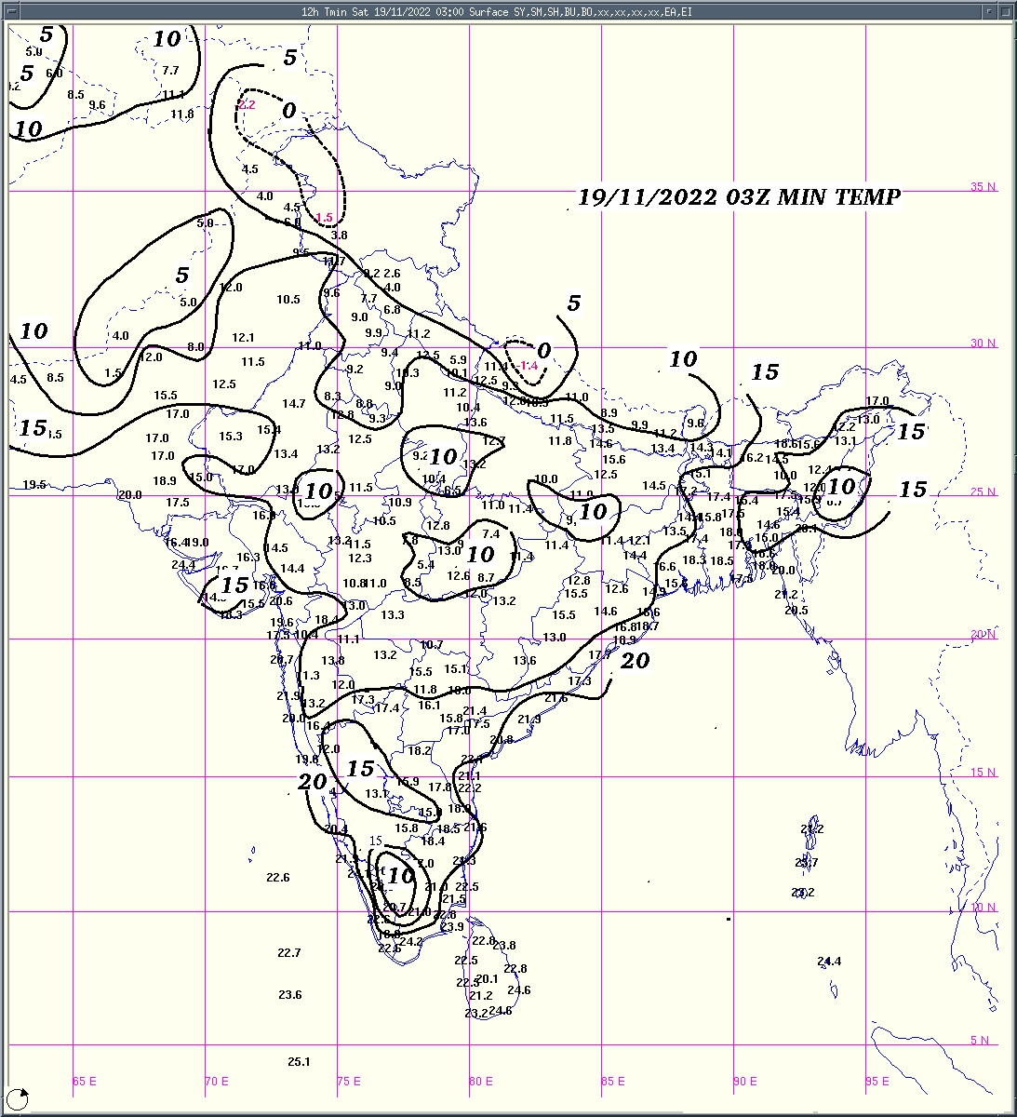 | 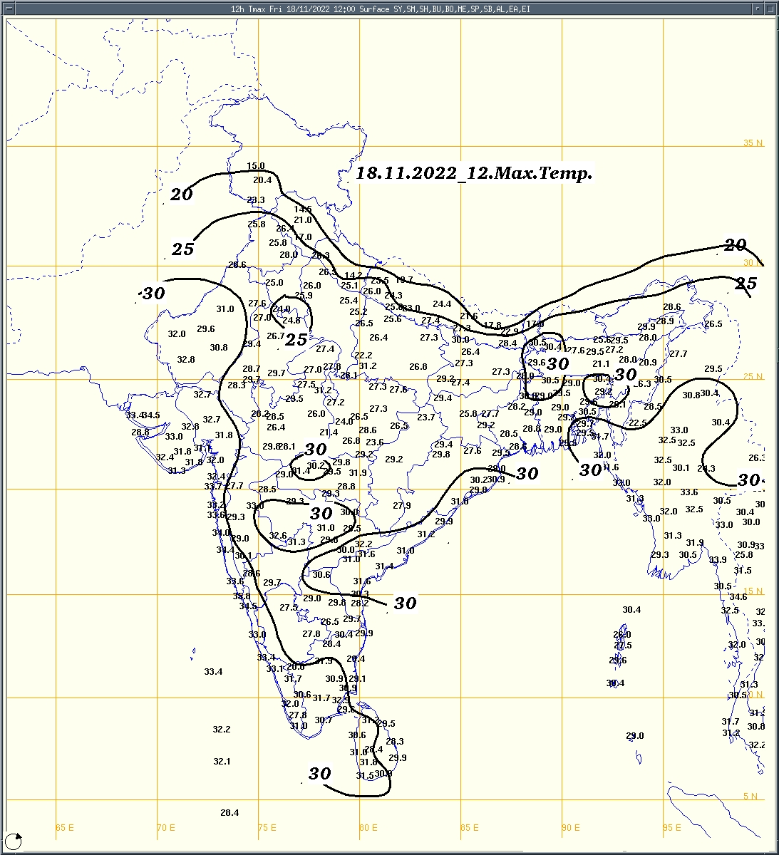 | 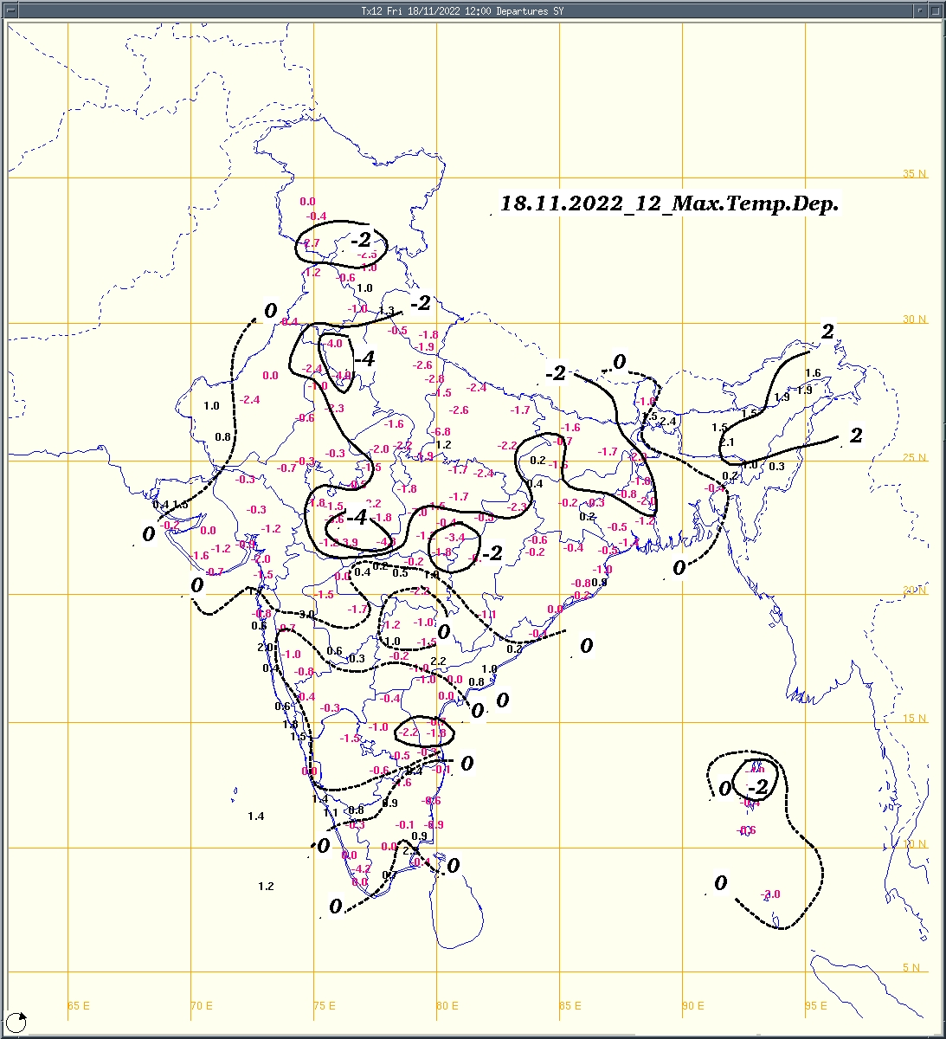
Fig.1a: Minimum temperature (⁰C) | Fig.2a: Maximum temperature (⁰C) | Fig.2b: Maximum temperature departure(⁰C)
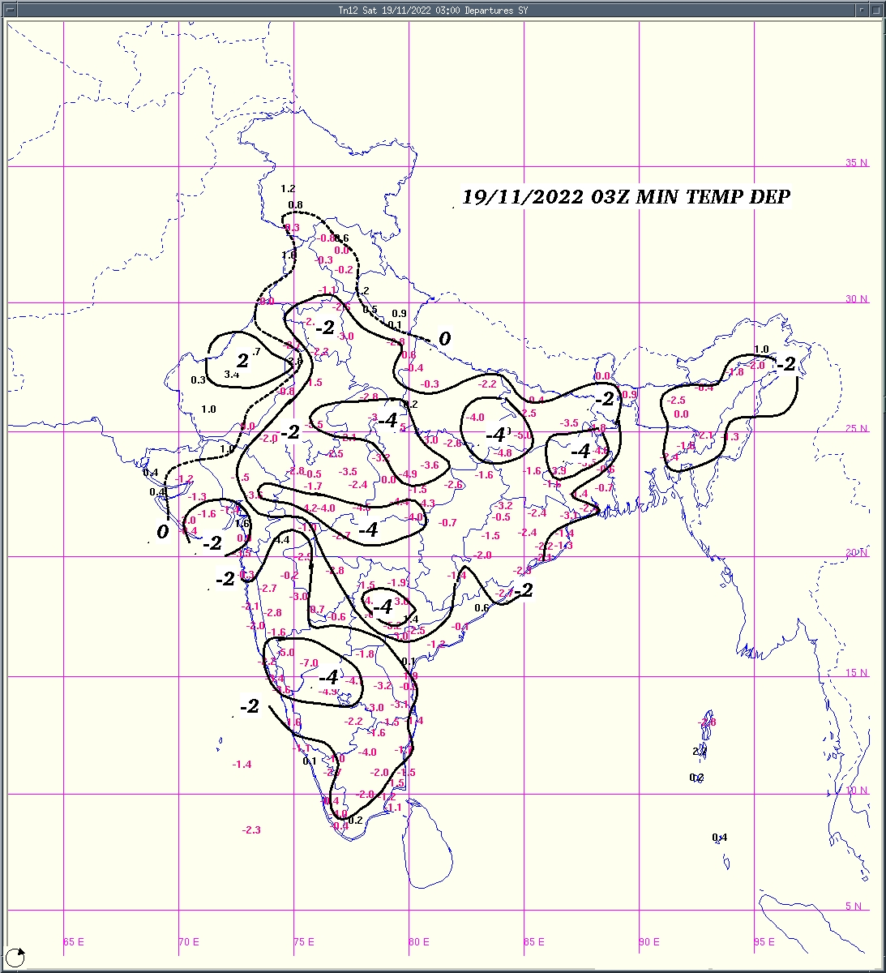  Fig.1b:Minimum temperature departure (⁰C) | 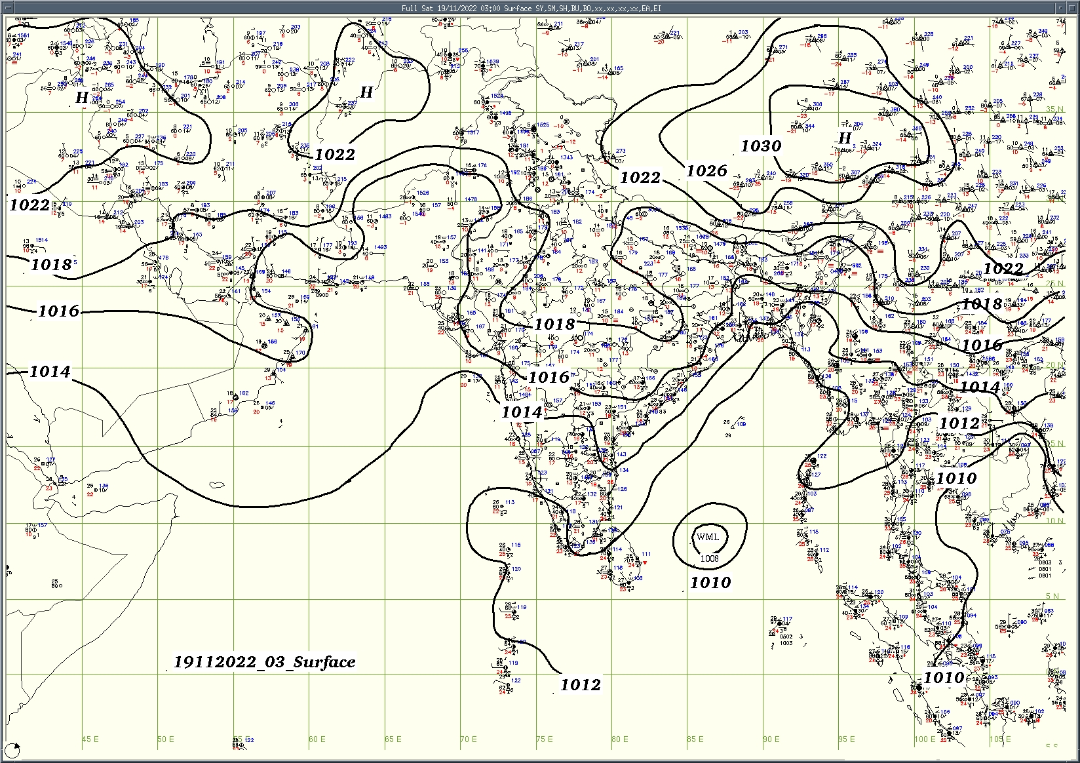  Fig.3: Analysed surface chart based on 03z observation

Dr. Anupam Kashyapi,
Scientist 'F'
CR & S Office, Pune  Issued at 1245 hrs. IST |  | Weather Forecasting Division

Indian Regions | Table 1. Realised rainfall (chief amount in cm during past 24 hrs)
East | dry weather: Arunachal Pradesh, Assam & Meghalaya, Nagaland-Manipur-Mizoram-Tripura, West Bengal & Sikkim, Odisha, Jharkhand and Bihar
North | dry weather: Uttar Pradesh, Uttarakhand, Haryana, Punjab, Himachal Pradesh, Jammu-Kashmir and Ladakh and Rajasthan
Central | dry weather: Madhya Pradesh, Vidarbha and Chhattisgarh
Peninsula | isolated places: coastal Andhra Pradesh◆, Tamil Nadu◆ and Kerala  dry weather: Gujarat State, Konkan & Goa, Madhya Maharashtra, Marathwada, Telangana, Rayalaseema, coastal Karnataka and interior Karnataka  West kallada AWS 0.5, Araku valley, Papanasam & Konni 0.2 each, Punalur 0.1.
Islands | a few places: Andaman & Nicobar  dry weather: Lakshadweep  Maya bandar 2.5, Long island 1.4, Nancowry 0.5.
Table 2. Forecast / warnings (distribution of rain / thundershowers) for 5 days (valid from time of origin upto 0830 hrs IST of next day)
Sr. No. | Sub-division Name | Day 1 | Day 2 | Day 3 | Day 4 | Day 5 | Sr. No. | Sub-division Name | Day 1 | Day 2 | Day 3 | Day 4 | Day 5
 |  | 19 Nov | 20 Nov | 21 Nov | 22 Nov | 23 Nov |  |  | 19 Nov | 20 Nov | 21 Nov | 22 Nov | 23 Nov
1 | Andaman Nicobar Islands | F | S | S | F | F | 19 | west Madhya Pradesh | D | D | D | D | D
2 | Arunachal Pradesh | D | D | D | D | D | 20 | east Madhya Pradesh | D | D | D | D | D
3 | Assam-Meghalaya | D | D | D | D | D | 21 | Gujarat Region | D | D | D | D | D
4 | Nagaland-Manipur-Mizoram-Tripura | D | D | D | D | D | 22 | Saurashtra and Kutch | D | D | D | D | D
5 | Sub Himalayan West Bengal/Sikkim | D | D | D | D | D | 23 | Konkan and Goa | D | D | D | D | D
6 | Gangetic West Bengal | D | D | D | D | D | 24 | Madhya Maharashtra | D | D | D | D | D
7 | Odisha | D | D | I | D | D | 25 | Marathwada | D | D | D | D | D
8 | Jharkhand | D | D | D | D | D | 26 | Vidarbha | D | D | D | D | D
9 | Bihar | D | D | D | D | D | 27 | Chhattisgarh | D | D | D | D | D
10 | east Uttar Pradesh | D | D | D | D | D | 28 | Coastal Andhra Pradesh and Yanam | I | I | S + | S + | I
11 | west Uttar Pradesh | D | D | D | D | D | 29 | Telangana | D | D | I | I | D
12 | Uttarakhand | D | D | D | D | D | 30 | Rayalaseema | D | I | I | S + | S
13 | Haryana, Chandigarh and Delhi | D | D | D | D | D | 31 | Tamil Nadu, Puducherry and Karaikal | I | S | S + | S + | S
14 | Punjab | D | D | D | D | D | 32 | Coastal Karnataka | D | D | D | I | I
15 | Himachal Pradesh | I | D | D | D | D | 33 | North interior Karnataka | D | D | D | D | I
16 | Jammu-Kashmir and Ladakh | S | I | D | D | D | 34 | South interior Karnataka | D | D | D | I | S
17 | west Rajasthan | D | D | D | D | D | 35 | Kerala and Mahe | I | I | I | I | I
18 | east Rajasthan | D | D | D | D | D | 36 | Lakshadweep | D | D | D | D | D
Legends: D = Dry I = Isolated S = Scattered F = Fairly widespread W = Widespread # = heavy to very heavy rain at a few places with extreamly heavy rain at isolated places +++= heavy rain at a few places with very heavy rain at isolated places ++= heavy to very heavy rainfall
+ = heavy rain ●/* = rain or snow ♦ = very light rain ≡ =fog = thunderstorm with lightning =Squall / Gusty wind / strong wind / gale wind -=cold wave/cold day +-= heat wave =Duststorm SS=ground frost = Hail
Fig. 4: Districtwise warnings for five days for Maharashtra State

Pune, Lohegaon and Pashan observations at 0830 hrs. IST of Today
 | Temperature (°C) |  |  |  |  |  |  |  |  |  |  |  | Humidity (%) |  |  |  |  |  |  |  | Rainfall (mm)
 | Max.  past  24 hrs |  |  | Dep.  from  normal |  |  | Min.  past  24 hrs. |  | Dep.  from  normal |  | Dry  Bulb |  | At 0830 hrs. IST |  |  | Dep.  From  normal |  | At 1730  hrs. IST of y’day |  | Dep.  from  normal | Past  24 hrs. | Since  1st Oct. | Dep.  from  normal
PNE | 29.3 |  |  | -0.8 |  |  | 11.3 |  | -3.0 |  | 16.8 |  | 82 |  |  | 5 |  | 54 |  | 9 | 0.0 | 303.5 | 207.1
PSN | 28.0 |  |  | - |  |  | 12.4 |  | - |  | 15.0 |  | 93 |  |  | - |  | 56 |  | - | 0.0 | 229.5 | -
LHG | 29.1 |  |  | -0.9 |  |  | 13.9 |  | -1.1 |  | 18.8 |  | 59 |  |  | -6 |  | 33 |  | -3 | 0.0 | 121.6 | 52.3
Local (Pune and neighbourhood) forecast)
Max. / Min. Temperature (°C) |  |  |  |  |  |  |  |  |  |  |  |  |  | Weather
Date | Pune |  | Pashan |  |  | Lohegaon |  | Chinchwad |  | Lavale |  | Magarpatta
19/11 | 28 / 11.3* |  | 27 / 12.4* |  |  | 28 / 13.9* |  | 29 / 16.9* |  | 29 / 16.8* |  | 28 / 17.3* |  | Sunny day.
20/11 | 29 / 12 |  | 28 / 13 |  |  | 29 / 14 |  | 29 / 17 |  | 30 / 17 |  | 28 / 18 |  | Sunny day.
21/11 | 29 / 12 |  | 28 / 13 |  |  | 29 / 15 |  | 30 / 18 |  | 30 / 18 |  | 29 / 18 |  | Mainly clear sky.
22/11 | 29 / 13 |  | 28 / 14 |  |  | 29 / 15 |  | 30 / 18 |  | 30 / 18 |  | 29 / 19 |  | Mainly clear sky.
23/11 | 30 / 13 |  | 29 / 14 |  |  | 29 / 15 |  | 30 / 19 |  | 31 / 19 |  | 29 / 19 |  | Mainly clear sky.
24/11 | 30 / 14 |  | 29 / 15 |  |  | 30 / 16 |  | 31 / 19 |  | 31 / 19 |  | 30 / 20 |  | Mainly clear sky.
25/11 | 30 / 14 |  | 29 / 15 |  |  | 30 / 16 |  | 31 / 20 |  | 31 / 19 |  | 30 / 20 |  | Mainly clear sky.
Mumbai (Colaba) |  |  |  |  |  |  |  |  |  |  |  |  |  |  | Nagpur (AP)
Date | Tmax °C | Tmin °C |  |  | Weather |  |  |  |  |  |  |  |  |  | Tmax °C |  | Tmin °C |  | Weather
19/11 | 33 | 23 |  |  | Clear sky. |  |  |  |  |  |  |  |  |  | 29 |  | 12 |  | Mainly clear sky.
20/11 | 33 | 23 |  |  | Mainly clear sky. |  |  |  |  |  |  |  |  |  | 29 |  | 11 |  | Mainly clear sky.
21/11 | 34 | 24 |  |  | Mainly clear sky. |  |  |  |  |  |  |  |  |  | 29 |  | 12 |  | Mainly clear sky.
22/11 | 34 | 24 |  |  | Partly cloudy sky. |  |  |  |  |  |  |  |  |  | 30 |  | 14 |  | Mainly clear sky.
23/11 | 34 | 24 |  |  | Mainly clear sky. |  |  |  |  |  |  |  |  |  | 30 |  | 14 |  | Mainly clear sky.
24/11 | 34 | 23 |  |  | Partly cloudy sky. |  |  |  |  |  |  |  |  |  | 29 |  | 13 |  | Mainly clear sky.
25/11 | 34 | 23 |  |  | Partly cloudy sky. |  |  |  |  |  |  |  |  |  | 29 |  | 13 |  | Mainly clear sky.

Widespread (W) | 76 - 100 |  |  |  |  | - Rainfall | Very light rain | trace to 2.4
Fairly widespread (F) | 51 - 75 |  |  |  |  |  | Light rain | 2.5 to 15.5
Scattered (S) | 26 - 50 |  |  |  |  |  | Moderate rain | 15.6 to 64.4
Isolated (I) | 1 - 25 |  |  |  |  |  | Heavy rain | 64.5 to 115.5
Dry (D) | No Rain |  |  |  |  |  | Very heavy rain | 115.6 to 204.4
Probability Terms in %: |  |  |  |  |  |  | Extremely heavy rain | ≥ 204.5
unlikely | < 25 |  |  |  |  | - Snowfall | Heavy snow | 6.5 to 11.5 cms water equivalent of rain
likely | between 25, 50 |  |  |  |  |  | Very heavy snow | 11.6 to 20.4 cms water equivalent of rain
very likely | between 51, 75
most likely | >75

